

ANSWER BOOKLET

NAME: ANSWERS

FORM: DATE:

Multiple Choice Short Answer Total

/10
/20

/30

/20
/25

SECTION ONE: Multiple choice answers
Cross (X) through the correct answer.
1 | a | X | c | d
2 | X | b | c | d
3 | a | b | X | d
4 | X | b | c | d
5 | a | b | X | d
6 | a | b | X | d
7 | a | b | X | d
8 | a | b | c | X
9 | X | b | c | d
10 | a | b | X | d

SECTION TWO: Short Answer (20 marks)
1. List two advantages that parallel circuits have over series circuits. (2 marks)

Any two:
- Shares voltage across all components / same brightness to all lights
- If one component breaks, the rest will continue working
- Easy to install switches to turn on/off individual components
2. Recall the following terms by matching each term (a to c) with its correct description ( i to iii).
(3 marks)
a) current → ii | i) measures how difficult it is for charges to pass through a material
b) voltage → iii | ii) measures the flow of charge passing through the circuit
c) resistance →i | iii) measures the energy provided to or used by charges

3. Look at the diagram below.
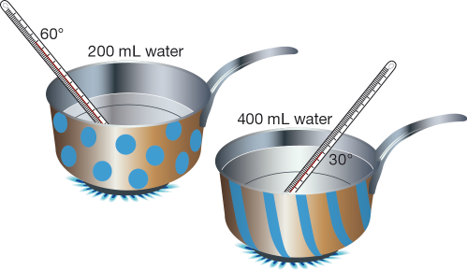
a) Explain why the base of each saucepan is metal, but the handles are made from a tough plastic. (2 marks)
- Metal saucepan is a conductor so it heats up food in the sauce pan faster
- Handle is plastic which is an insulator to prevent the handle from getting hot and burning people

b) Why does the water in the spotty saucepan heat up faster? (1 mark)

- has less water to heat up
4. A torch light is made up of
- 2 batteries
- Switch
- Light bulb
- Draw a LABELLED circuit diagram below (4 marks)
1 - switch
1 – light bulb
1 – TWO cells
1 – circuit connected
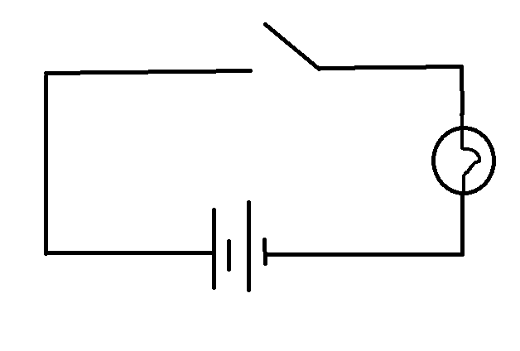
- If each of the batteries is 1.5V. What’s the total voltage needed to power the torch light? ( 1 mark)
3V
5. Below draw a circuit diagram of the following (4 marks)
- Voltage source / battery
- 3 light bulbs in parallel
- Switch to turn on and off ALL the lights
- Ammeter measuring the current for 1 light bulb
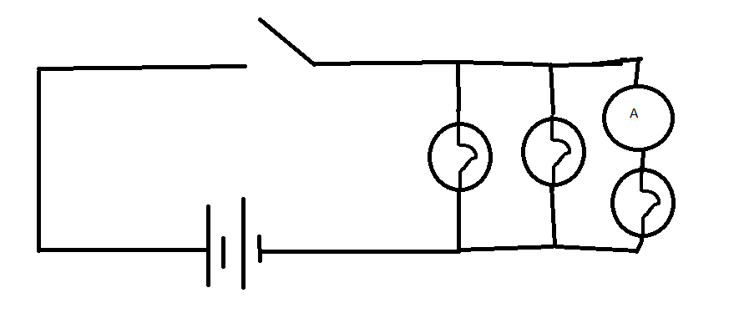
-1 – 3 lights in parallel
-1 – ammeter IN SERIES with one light
-1 – Switch located in CORRECT place
-1 – Voltage source in CORRECT place
6. In the household, there are some measures taken when there is an overload in the household appliances.
a) Explain how fuses OR circuit breakers work in that situation. (2 marks)
Fuses or circuit breakers work when there is a large residual current
The current will melt the fuse, or pull the circuit apart with the breaker and stop electricity from flowing
b) What are 2 disadvantages for fuses compared to circuit breakers (1 mark)
Fuses need replacing
Works slower than circuit breakers

